**Web Scraping – Challenge**

**Question:** Write a Python application to scrape the data from the following web site as per the directions given.

<http://quotes.toscrape.com/>

Data from the first 5 pages of this site need to be scraped.

1. The output of your Python code should be displayed as shown below.

Quote: The world as we have created it is a process of our thinking. It cannot be changed without changing our thinking.

Author: Albert Einstein

Tags: change;deep-thoughts;thinking;world

Quote: It is our choices, Harry, that show what we truly are, far more than our abilities.

Author: J.K. Rowling

Tags: abilities;choices

Quote: There are only two ways to live your life. One is as though nothing is a miracle. The other is as though everything is a miracle.

Author: Albert Einstein

Tags: inspirational;life;live;miracle;miracles

1. The scraped data is to be loaded into a Pandas dataframe and written into a CSV file as shown in the format below:

|  |  |  |  |
| --- | --- | --- | --- |
|  | Author | Quote | Tags |
| 0 | Albert Einstein | The world as we have created it is a process of our thinking. It cannot be changed without changing our thinking. | change;deep-thoughts;thinking;world |
| 1 | J.K. Rowling | It is our choices, Harry, that show what we truly are, far more than our abilities. | abilities;choices |
| 2 | Albert Einstein | There are only two ways to live your life. One is as though nothing is a miracle. The other is as though everything is a miracle. | inspirational;life;live;miracle;miracles |

1. As part of each quote a hyperlink is also present as highlighted in the screen shot below.

It points to a web page about the author.

Modify your code to extract the hyperlink as well and display it as shown below.

Similarly the Python program needs to save the link in the dataframe as a column (series) and save it to the CSV file also.

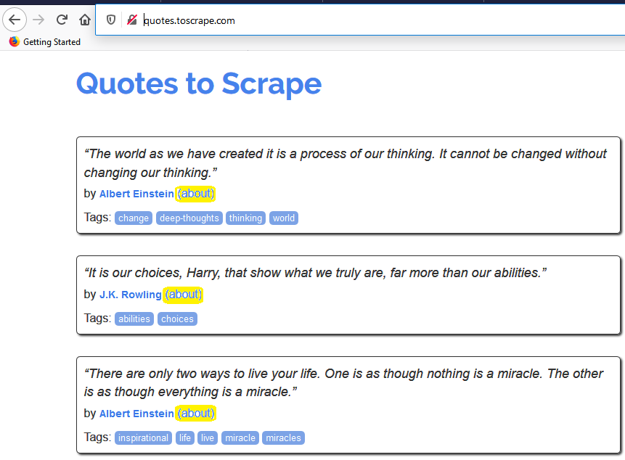

It points to a web page about the author.

Modify your code to extract the hyperlink as well and display it as shown below.

Quote: The world as we have created it is a process of our thinking. It cannot be changed without changing our thinking.

Author: Albert Einstein

About: http://quotes.toscrape.com/author/Albert-Einstein

Tags: change;deep-thoughts;thinking;world

Quote: It is our choices, Harry, that show what we truly are, far more than our abilities.

Author: J.K. Rowling

About: http://quotes.toscrape.com/author/J-K-Rowling

Tags: abilities;choices

Quote: There are only two ways to live your life. One is as though nothing is a miracle. The other is as though everything is a miracle.

Author: Albert Einstein

About: http://quotes.toscrape.com/author/Albert-Einstein

Tags: inspirational;life;live;miracle;miracles

Similarly the Python program needs to save the link in the dataframe as a column (series) and save it to the CSV file also.

|  |  |  |  |  |
| --- | --- | --- | --- | --- |
|  | About | Author | Quote | Tags |
| 0 | http://quotes.toscrape.com/author/Albert-Einstein | Albert Einstein | The world as we have created it is a process of our thinking. It cannot be changed without changing our thinking. | change;deep-thoughts;thinking;world |
| 1 | http://quotes.toscrape.com/author/J-K-Rowling | J.K. Rowling | It is our choices, Harry, that show what we truly are, far more than our abilities. | abilities;choices |
| 2 | http://quotes.toscrape.com/author/Albert-Einstein | Albert Einstein | There are only two ways to live your life. One is as though nothing is a miracle. The other is as though everything is a miracle. | inspirational;life;live;miracle;miracles |